**VISVESVARAYA TECHNOLOGICAL UNIVERSITY**

**“JnanaSangama”, Belgaum -590014, Karnataka.**



**LAB REPORT**

**on**

**Artificial Intelligence**

***Submitted by***

**VISHWANATHA (1BM22CS421)**

***in partial fulfillment for the award of the degree of***

**BACHELOR OF ENGINEERING**

***in***

**COMPUTER SCIENCE AND ENGINEERING**



**B.M.S. COLLEGE OF ENGINEERING**

**(Autonomous Institution under VTU)**

**BENGALURU-560019**

**Nov-2023 to Feb-2024**

**B. M. S. College of Engineering,**

**Bull Temple Road, Bangalore 560019**

(Affiliated To Visvesvaraya Technological University, Belgaum)

**Department of Computer Science and Engineering**



**CERTIFICATE**

This is to certify that the Lab work entitled “**Artificial Intelligence**” carried out by **VISHWANATHA (1BM22CS421),** who is bonafide student of **B.M.S. College of Engineering.** It is in partial fulfillment for the award of **Bachelor of Engineering in Computer Science and Engineering** of the Visvesvaraya Technological University, Belgaum during the academic semester June-2023 to Sep-2023. The Lab report has been approved as it satisfies the academic requirements in respect of a **Artificial Intelligence (22CS5PCAIN)** work prescribed for the said degree.

**Dr. Swathi S**  **Dr. Jyothi S Nayak**

Associate Professor Professor and Head

Department of CSE Department of CSE

BMSCE, Bengaluru BMSCE, Bengaluru

**Index Sheet**

|  |  |  |
| --- | --- | --- |
| **Lab Program No.** | **Program Details** | **Page No.** |
| 1 | Implement Tic –Tac –Toe Game. | 1 - 6 |
| 2 | Solve 8 puzzle problems. | 7 - 10 |
| 3 | Implement Iterative deepening search algorithm. | 11 - 14 |
| 4 | Implement A* search algorithm. | 15 - 19 |
| 5 | Implement vaccum cleaner agent. | 20 - 22 |
| 6 | Create a knowledge base using prepositional logic and show that  the given query entails the knowledge base or not. | 23 - 24 |
| 7 | Create a knowledge base using prepositional logic and prove the  given query using resolution | 25 - 29 |
| 8 | Implement unification in first order logic | 30 - 35 |
| 9 | Convert a given first order logic statement into Conjunctive  Normal Form (CNF). | 36 - 37 |
| 10 | Create a knowledge base consisting of first order logic statements  and prove the given query using forward reasoning. | 38 - 42 |

**Course Outcome**

|  |  |
| --- | --- |
| CO1 | Apply knowledge of agent architecture, searching and reasoning techniques for different applications. |
| CO2 | Analyse Searching and Inferencing Techniques. |
| CO3 | Design a reasoning system for a given requirement. |
| CO4 | Conduct practical experiments for demonstrating agents, searching and inferencing. |

1. **Implement Tic –Tac –Toe Game.**

import math

import copy

X = "X"

O = "O"

EMPTY = None

def initial_state():

return [[EMPTY, EMPTY, EMPTY],

[EMPTY, EMPTY, EMPTY],

[EMPTY, EMPTY, EMPTY]]

def player(board):

countO = 0

countX = 0

for y in [0, 1, 2]:

for x in board[y]:

if x == "O":

countO = countO + 1

elif x == "X":

countX = countX + 1

if countO >= countX:

return X

elif countX > countO:

return O

def actions(board):

freeboxes = set()

for i in [0, 1, 2]:

for j in [0, 1, 2]:

if board[i][j] == EMPTY:

freeboxes.add((i, j))

return freeboxes

def result(board, action):

i = action[0]

j = action[1]

if type(action) == list:

action = (i, j)

if action in actions(board):

if player(board) == X:

board[i][j] = X

elif player(board) == O:

board[i][j] = O

return board

def winner(board):

if (board[0][0] == board[0][1] == board[0][2] == X or board[1][0] == board[1][1] == board[1][2] == X or board[2][0] == board[2][1] == board[2][2] == X):

return X

if (board[0][0] == board[0][1] == board[0][2] == O or board[1][0] == board[1][1] == board[1][2] == O or board[2][0] == board[2][1] == board[2][2] == O):

return O

for i in [0, 1, 2]:

s2 = []

for j in [0, 1, 2]:

s2.append(board[j][i])

if (s2[0] == s2[1] == s2[2]):

return s2[0]

strikeD = []

for i in [0, 1, 2]:

strikeD.append(board[i][i])

if (strikeD[0] == strikeD[1] == strikeD[2]):

return strikeD[0]

if (board[0][2] == board[1][1] == board[2][0]):

return board[0][2]

return None

def terminal(board):

Full = True

for i in [0, 1, 2]:

for j in board[i]:

if j is None:

Full = False

if Full:

return True

if (winner(board) is not None):

return True

return False

def utility(board):

if (winner(board) == X):

return 1

elif winner(board) == O:

return -1

else:

return 0

def minimax_helper(board):

isMaxTurn = True if player(board) == X else False

if terminal(board):

return utility(board)

scores = []

for move in actions(board):

result(board, move)

scores.append(minimax_helper(board))

board[move[0]][move[1]] = EMPTY

return max(scores) if isMaxTurn else min(scores)

def minimax(board):

isMaxTurn = True if player(board) == X else False

bestMove = None

if isMaxTurn:

bestScore = -math.inf

for move in actions(board):

result(board, move)

score = minimax_helper(board)

board[move[0]][move[1]] = EMPTY

if (score > bestScore):

bestScore = score

bestMove = move

return bestMove

else:

bestScore = +math.inf

for move in actions(board):

result(board, move)

score = minimax_helper(board)

board[move[0]][move[1]] = EMPTY

if (score < bestScore):

bestScore = score

bestMove = move

return bestMove

def print_board(board):

for row in board:

print(row)

# Example usage:

game_board = initial_state()

print("Initial Board:")

print_board(game_board)

while not terminal(game_board):

if player(game_board) == X:

user_input = input("\nEnter your move (row, column): ")

row, col = map(int, user_input.split(','))

result(game_board, (row, col))

else:

print("\nAI is making a move...")

move = minimax(copy.deepcopy(game_board))

result(game_board, move)

print("\nCurrent Board:")

print_board(game_board)

# Determine the winner

if winner(game_board) is not None:

print(f"\nThe winner is: {winner(game_board)}")

else:

print("\nIt's a tie!")

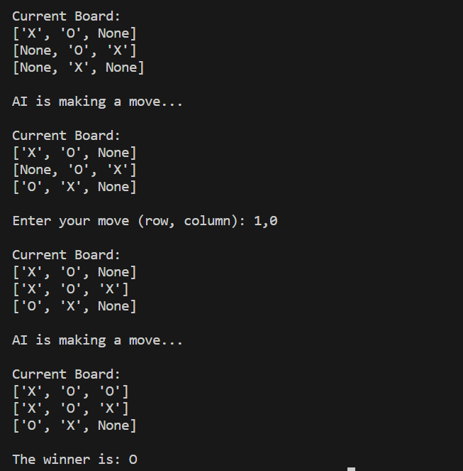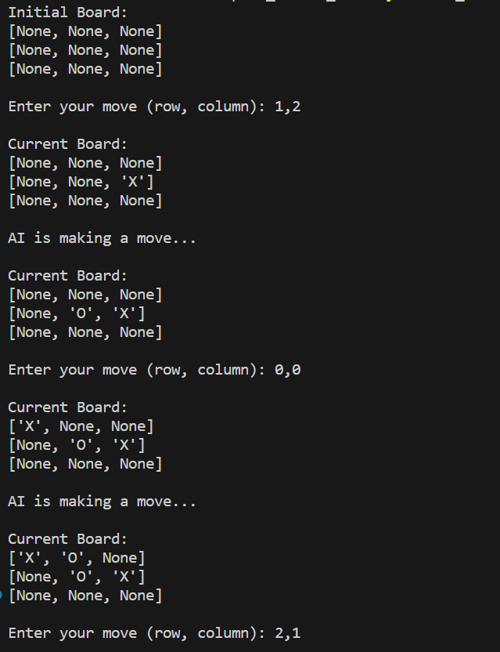**OUTPUT**:

1. **Solve 8 puzzle problems.**

def bfs(src,target):

queue = []

queue.append(src)

exp = []

while len(queue) > 0:

source = queue.pop(0)

exp.append(source)

print(source)

if source==target:

print("Success")

return

poss_moves_to_do = []

poss_moves_to_do = possible_moves(source,exp)

for move in poss_moves_to_do:

if move not in exp and move not in queue:

queue.append(move)

def possible_moves(state,visited_states):

#index of empty spot

b = state.index(0)

#directions array

d = []

#Add all the possible directions

if b not in [0,1,2]:

d.append('u')

if b not in [6,7,8]:

d.append('d')

if b not in [0,3,6]:

d.append('l')

if b not in [2,5,8]:

d.append('r')

# If direction is possible then add state to move

pos_moves_it_can = []

# for all possible directions find the state if that move is played

### Jump to gen function to generate all possible moves in the given directions

for i in d:

pos_moves_it_can.append(gen(state,i,b))

return [move_it_can for move_it_can in pos_moves_it_can if move_it_can not in visited_states]

def gen(state, m, b):

temp = state.copy()

if m=='d':

temp[b+3],temp[b] = temp[b],temp[b+3]

if m=='u':

temp[b-3],temp[b] = temp[b],temp[b-3]

if m=='l':

temp[b-1],temp[b] = temp[b],temp[b-1]

if m=='r':

temp[b+1],temp[b] = temp[b],temp[b+1]

# return new state with tested move to later check if "src == target"

return temp

print("Example 1")

src= [2,0,3,1,8,4,7,6,5]

target=[1,2,3,8,0,4,7,6,5]

print("Source: " , src)

print("Goal State: " , target)

bfs(src, target)

print("\nExample 2")

src = [1,2,3,0,4,5,6,7,8]

target = [1,2,3,4,5,0,6,7,8]

print("Source: " , src)

print("Goal State: " , target)

bfs(src, target)

**OUTPUT:**

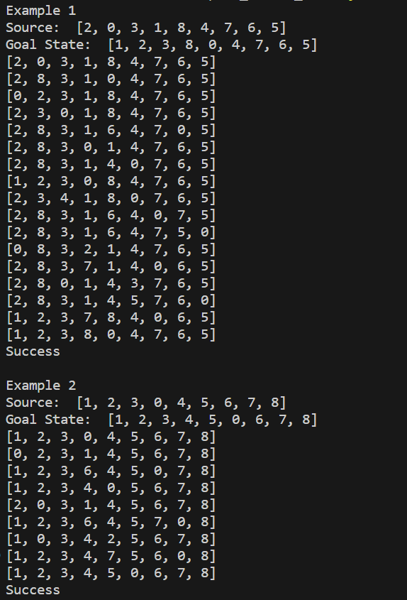

1. **Implement Iterative deepening search algorithm.**

def iterative_deepening_search(src, target):

depth_limit = 0

while True:

result = depth_limited_search(src, target, depth_limit, [])

if result is not None:

print("Success")

return

depth_limit += 1

if depth_limit > 30: # Set a reasonable depth limit to avoid an infinite loop

print("Solution not found within depth limit.")

return

def depth_limited_search(src, target, depth_limit, visited_states):

if src == target:

print_state(src)

return src

if depth_limit == 0:

return None

visited_states.append(src)

poss_moves_to_do = possible_moves(src, visited_states)

for move in poss_moves_to_do:

if move not in visited_states:

print_state(move)

result = depth_limited_search(move, target, depth_limit - 1, visited_states)

if result is not None:

return result

return None

def possible_moves(state, visited_states):

b = state.index(0)

d = []

if b not in [0, 1, 2]:

d.append('u')

if b not in [6, 7, 8]:

d.append('d')

if b not in [0, 3, 6]:

d.append('l')

if b not in [2, 5, 8]:

d.append('r')

pos_moves_it_can = []

for i in d:

pos_moves_it_can.append(gen(state, i, b))

return [move_it_can for move_it_can in pos_moves_it_can if move_it_can not in visited_states]

def gen(state, m, b):

temp = state.copy()

if m == 'd':

temp[b + 3], temp[b] = temp[b], temp[b + 3]

elif m == 'u':

temp[b - 3], temp[b] = temp[b], temp[b - 3]

elif m == 'l':

temp[b - 1], temp[b] = temp[b], temp[b - 1]

elif m == 'r':

temp[b + 1], temp[b] = temp[b], temp[b + 1]

return temp

def print_state(state):

print(f"{state[0]} {state[1]} {state[2]}\n{state[3]} {state[4]} {state[5]}\n{state[6]} {state[7]} {state[8]}\n")

print("Example 1")

src = [1,2,3,0,4,5,6,7,8]

target = [1,2,3,4,5,0,6,7,8]

print("Source: " , src)

print("Goal State: " , target)

iterative_deepening_search(src, target)

**OUTPUT:**

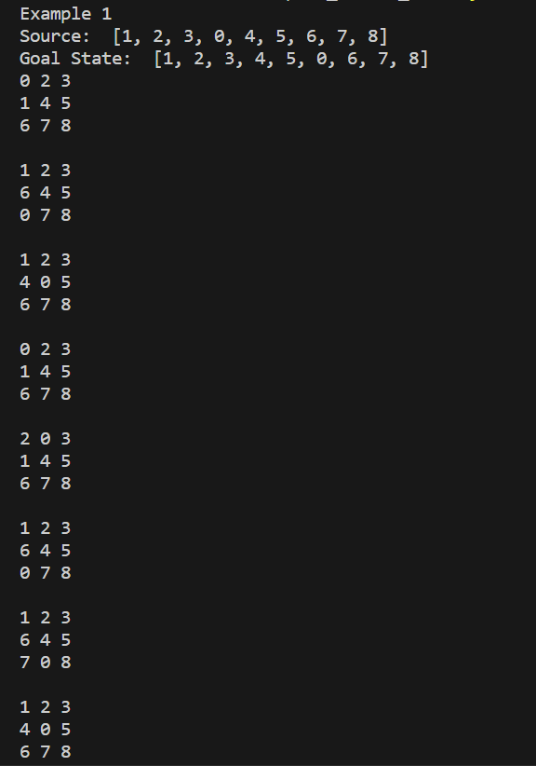

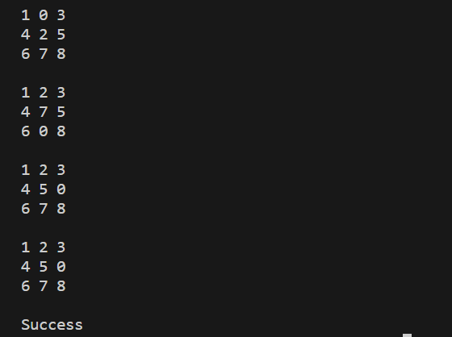

1. **Implement A* search algorithm.**

def print_grid(src):

state = src.copy()

state[state.index(-1)] = ' '

print(

f"""

{state[0]} {state[1]} {state[2]}

{state[3]} {state[4]} {state[5]}

{state[6]} {state[7]} {state[8]}

"""

)

def h(state, target):

#Manhattan distance

dist = 0

for i in state:

d1, d2 = state.index(i), target.index(i)

x1, y1 = d1 % 3, d1 // 3

x2, y2 = d2 % 3, d2 // 3

dist += abs(x1-x2) + abs(y1-y2)

return dist

def astar(src, target):

states = [src]

g = 0

visited_states = set()

while len(states):

moves = []

for state in states:

visited_states.add(tuple(state))

print_grid(state)

if state == target:

print("Success")

return

moves += [move for move in possible_moves(state, visited_states) if move not in moves]

costs = [g + h(move, target) for move in moves]

states = [moves[i] for i in range(len(moves)) if costs[i] == min(costs)]

g += 1

print("Fail")

def possible_moves(state, visited_states):

b = state.index(-1)

d = []

if 9 > b - 3 >= 0:

d += 'u'

if 9 > b + 3 >= 0:

d += 'd'

if b not in [2,5,8]:

d += 'r'

if b not in [0,3,6]:

d += 'l'

pos_moves = []

for move in d:

pos_moves.append(gen(state,move,b))

return [move for move in pos_moves if tuple(move) not in visited_states]

def gen(state, direction, b):

temp = state.copy()

if direction == 'u':

temp[b-3], temp[b] = temp[b], temp[b-3]

if direction == 'd':

temp[b+3], temp[b] = temp[b], temp[b+3]

if direction == 'r':

temp[b+1], temp[b] = temp[b], temp[b+1]

if direction == 'l':

temp[b-1], temp[b] = temp[b], temp[b-1]

return temp

#Test 1

print("Example 1")

src = [1,2,3,-1,4,5,6,7,8]

target = [1,2,3,4,5,-1,6,7,8]

print("Source: " , src)

print("Goal State: " , target)

astar(src, target)

# Test 2

print("Example 2")

src = [1,2,3,-1,4,5,6,7,8]

target=[1,2,3,6,4,5,-1,7,8]

print("Source: " , src)

print("Goal State: " , target)

astar(src, target)

# Test 3

print("Example 3")

src = [1,2,3,7,4,5,6,-1,8]

target=[1,2,3,6,4,5,-1,7,8]

print("Source: " , src)

print("Goal State: " , target)

astar(src, target)

**OUTPUT:**

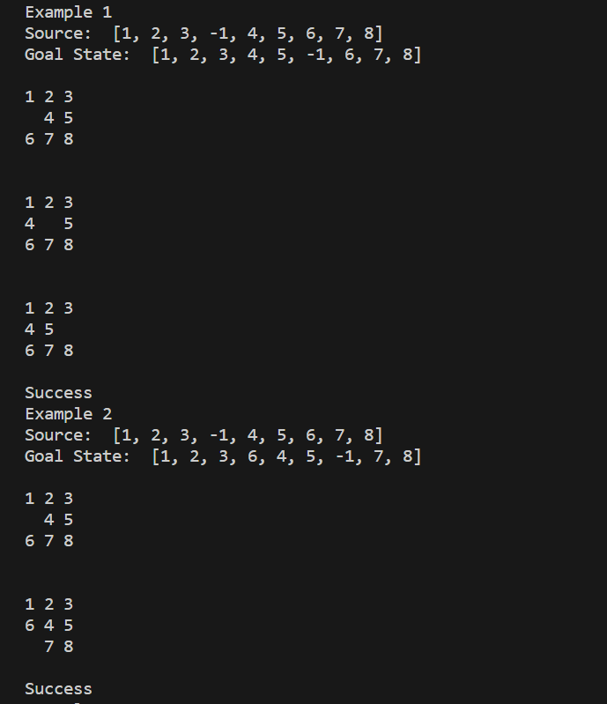

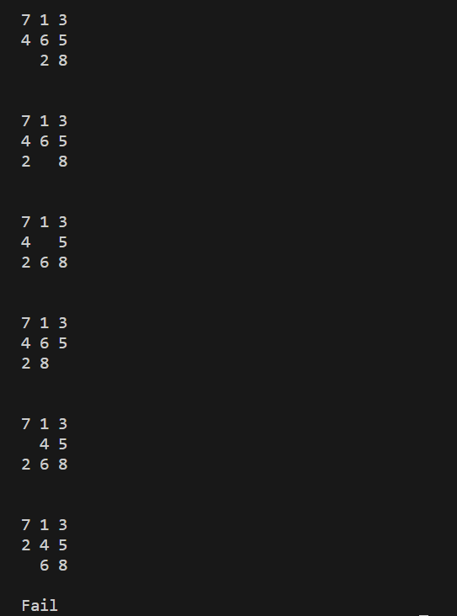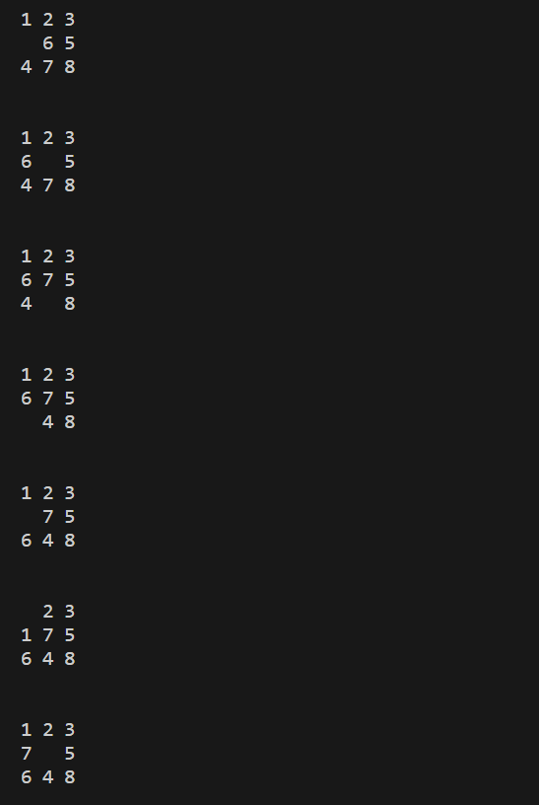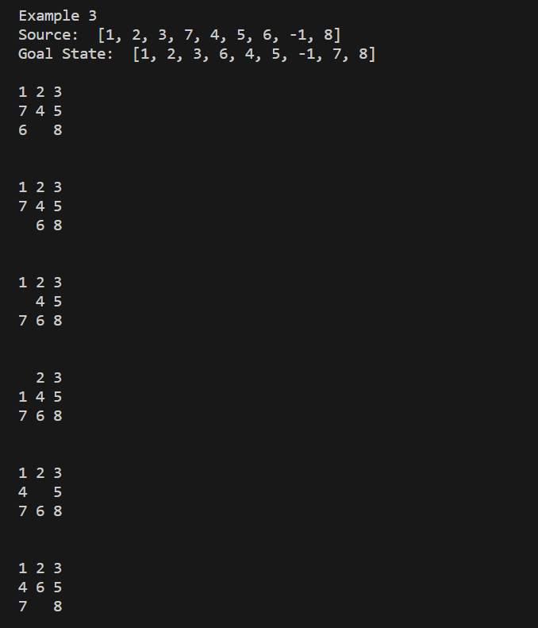

1. **Implement vacuum cleaner agent.**

def clean(floor, row, col):

i, j, m, n = row, col, len(floor), len(floor[0])

goRight = goDown = True

cleaned = [not any(f) for f in floor]

while not all(cleaned):

while any(floor[i]):

print_floor(floor, i, j)

if floor[i][j]:

floor[i][j] = 0

print_floor(floor, i, j)

if not any(floor[i]):

cleaned[i] = True

break

if j == n - 1:

j -= 1

goRight = False

elif j == 0:

j += 1

goRight = True

else:

j += 1 if goRight else -1

if all(cleaned):

break

if i == m - 1:

i -= 1

goDown = False

elif i == 0:

i += 1

goDown = True

else:

i += 1 if goDown else -1

if cleaned[i]:

print_floor(floor, i, j)

def print_floor(floor, row, col): # row, col represent the current vacuum cleaner position

for r in range(len(floor)):

for c in range(len(floor[r])):

if r == row and c == col:

print(f" >{floor[r][c]}< ", end = '')

else:

print(f" {floor[r][c]} ", end = '')

print(end = '\n')

print(end = '\n')

# Test 1

floor = [[1, 0, 0, 0],

[0, 1, 0, 1],

[1, 0, 1, 1]]

print("Room Condition: ")

for row in floor:

print(row)

print("\n")

clean(floor, 1, 2)

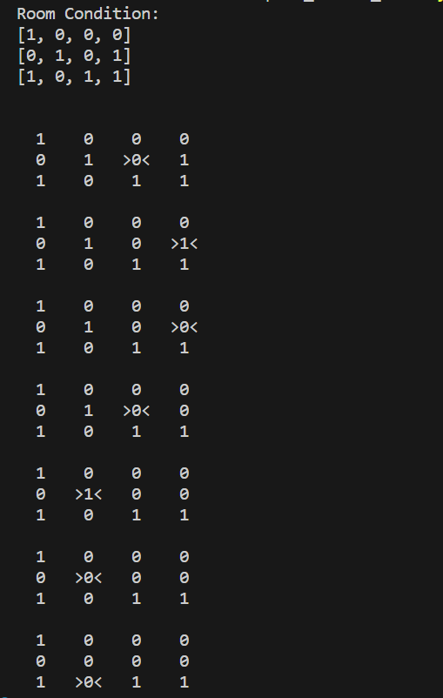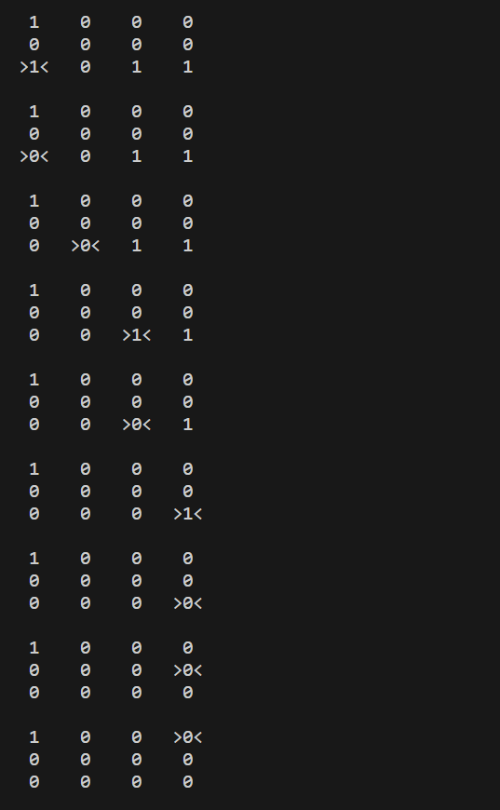O**UTPUT:**

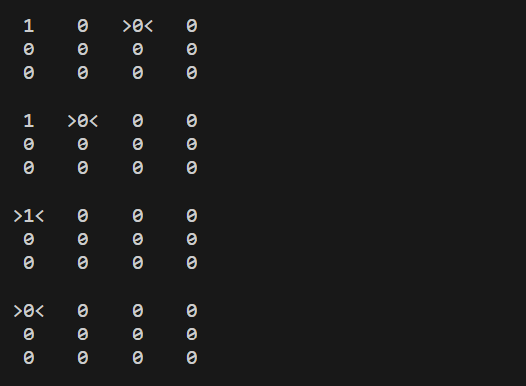

1. **Create a knowledge base using prepositional logic and show that the given query entails the knowledge base or not.**

def evaluate_expression(p, q, r):

expression_result = (p or q) and (not r or p)

return expression_result

def generate_truth_table():

print(" p | q | r | Expression (KB) | Query (p^r)")

print("---|---|---|-----------------|------------")

for p in [True, False]:

for q in [True, False]:

for r in [True, False]:

expression_result = evaluate_expression(p, q, r)

query_result = p and r

print(f" {p} | {q} | {r} | {expression_result} | {query_result}")

def query_entails_knowledge():

for p in [True, False]:

for q in [True, False]:

for r in [True, False]:

expression_result = evaluate_expression(p, q, r)

query_result = p and r

if expression_result and not query_result:

return False

return True

def main():

generate_truth_table()

if query_entails_knowledge():

print("\nQuery entails the knowledge.")

else:

print("\nQuery does not entail the knowledge.")

if __name__ == "__main__":

main()

**OUTPUT:**

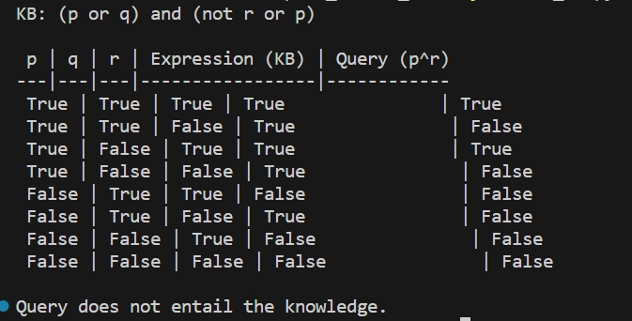

1. **Create a knowledge base using prepositional logic and prove the given query using resolution**

import re

def main(rules, goal):

rules = rules.split(' ')

steps = resolve(rules, goal)

print('\nStep\t|Clause\t|Derivation\t')

print('-' * 30)

i = 1

for step in steps:

print(f' {i}.\t| {step}\t| {steps[step]}\t')

i += 1

def negate(term):

return f'~{term}' if term[0] != '~' else term[1]

def reverse(clause):

if len(clause) > 2:

t = split_terms(clause)

return f'{t[1]}v{t[0]}'

return ''

def split_terms(rule):

exp = '(~*[PQRS])'

terms = re.findall(exp, rule)

return terms

split_terms('~PvR')

def contradiction(goal, clause):

contradictions = [ f'{goal}v{negate(goal)}', f'{negate(goal)}v{goal}']

return clause in contradictions or reverse(clause) in contradictions

def resolve(rules, goal):

temp = rules.copy()

temp += [negate(goal)]

steps = dict()

for rule in temp:

steps[rule] = 'Given.'

steps[negate(goal)] = 'Negated conclusion.'

i = 0

while i < len(temp):

n = len(temp)

j = (i + 1) % n

clauses = []

while j != i:

terms1 = split_terms(temp[i])

terms2 = split_terms(temp[j])

for c in terms1:

if negate(c) in terms2:

t1 = [t for t in terms1 if t != c]

t2 = [t for t in terms2 if t != negate(c)]

gen = t1 + t2

if len(gen) == 2:

if gen[0] != negate(gen[1]):

clauses += [f'{gen[0]}v{gen[1]}']

else:

if contradiction(goal,f'{gen[0]}v{gen[1]}'):

temp.append(f'{gen[0]}v{gen[1]}')

steps[''] = f"Resolved {temp[i]} and {temp[j]} to {temp[-1]}, which is in turn null. \

\nA contradiction is found when {negate(goal)} is assumed as true. Hence, {goal} is true."

return steps

elif len(gen) == 1:

clauses += [f'{gen[0]}']

else:

if contradiction(goal,f'{terms1[0]}v{terms2[0]}'):

temp.append(f'{terms1[0]}v{terms2[0]}')

steps[''] = f"Resolved {temp[i]} and {temp[j]} to {temp[-1]}, which is in turn null. \

\nA contradiction is found when {negate(goal)} is assumed as true. Hence, {goal} is true."

return steps

for clause in clauses:

if clause not in temp and clause != reverse(clause) and reverse(clause) not in temp:

temp.append(clause)

steps[clause] = f'Resolved from {temp[i]} and {temp[j]}.'

j = (j + 1) % n

i += 1

return steps

rules = 'Rv~P Rv~Q ~RvP ~RvQ' #(P^Q)<=>R : (Rv~P)v(Rv~Q)^(~RvP)^(~RvQ)

goal = 'R'

print('Rules: ',rules)

print("Goal: ",goal)

main(rules, goal)

rules = 'PvQ ~PvR ~QvR' #P=vQ, P=>Q : ~PvQ, Q=>R, ~QvR

goal = 'R'

print('Rules: ',rules)

print("Goal: ",goal)

main(rules, goal)

rules = 'PvQ PvR ~PvR RvS Rv~Q ~Sv~Q' # (P=>Q)=>Q, (P=>P)=>R, (R=>S)=>~(S=>Q)

goal = 'R'

print('Rules: ',rules)

print("Goal: ",goal)

main(rules, goal)

**OUTPUT:**

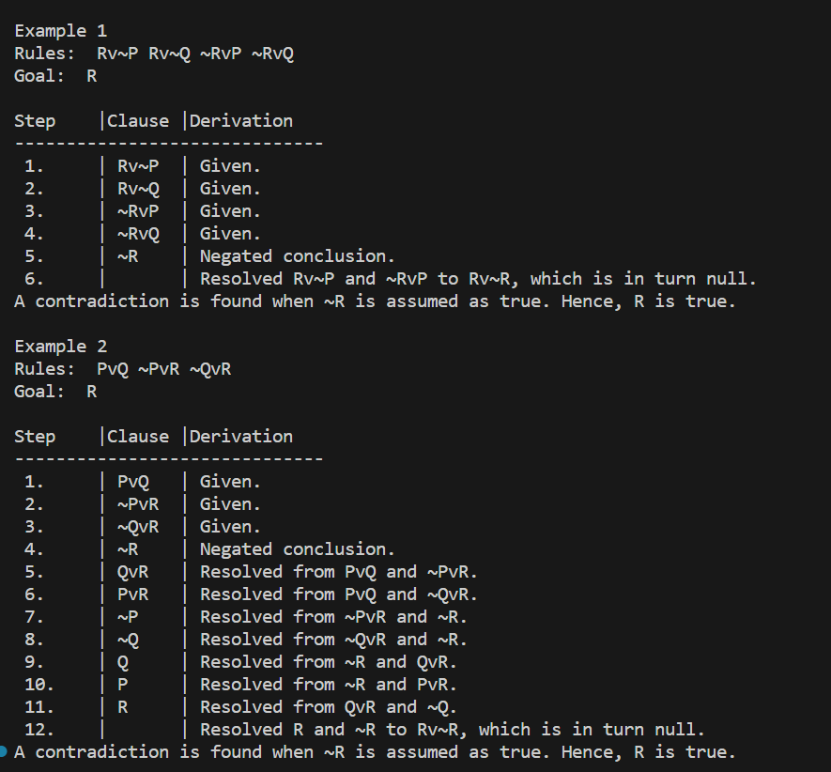

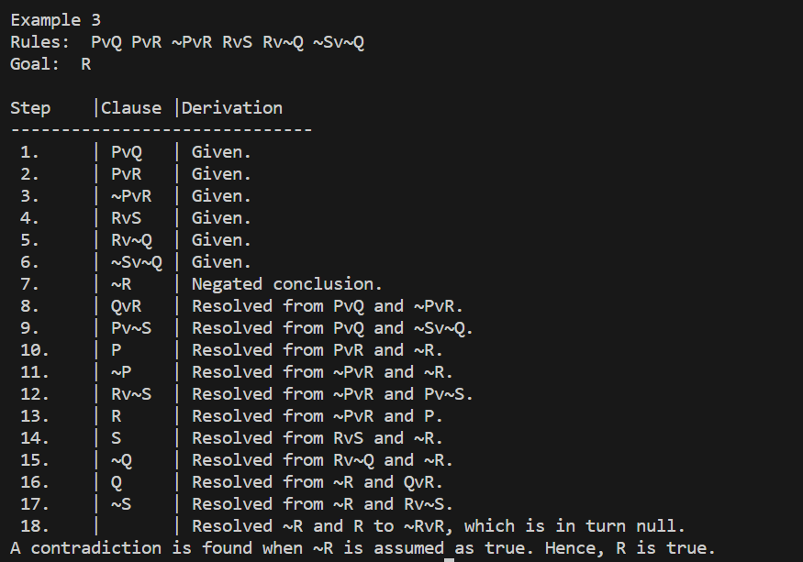

1. **Implement unification in first order logic**

import re

def getAttributes(expression):

expression = expression.split("(")[1:]

expression = "(".join(expression)

expression = expression[:-1]

expression = re.split("(?<!\(.),(?!.\))", expression)

return expression

def getInitialPredicate(expression):

return expression.split("(")[0]

def isConstant(char):

return char.isupper() and len(char) == 1

def isVariable(char):

return char.islower() and len(char) == 1

def replaceAttributes(exp, old, new):

attributes = getAttributes(exp)

for index, val in enumerate(attributes):

if val == old:

attributes[index] = new

predicate = getInitialPredicate(exp)

return predicate + "(" + ",".join(attributes) + ")"

def apply(exp, substitutions):

for substitution in substitutions:

new, old = substitution

exp = replaceAttributes(exp, old, new)

return exp

def checkOccurs(var, exp):

if exp.find(var) == -1:

return False

return True

def getFirstPart(expression):

attributes = getAttributes(expression)

return attributes[0]

def getRemainingPart(expression):

predicate = getInitialPredicate(expression)

attributes = getAttributes(expression)

newExpression = predicate + "(" + ",".join(attributes[1:]) + ")"

return newExpression

def unify(exp1, exp2):

if exp1 == exp2:

return []

if isConstant(exp1) and isConstant(exp2):

if exp1 != exp2:

return False

if isConstant(exp1):

return [(exp1, exp2)]

if isConstant(exp2):

return [(exp2, exp1)]

if isVariable(exp1):

if checkOccurs(exp1, exp2):

return False

else:

return [(exp2, exp1)]

if isVariable(exp2):

if checkOccurs(exp2, exp1):

return False

else:

return [(exp1, exp2)]

if getInitialPredicate(exp1) != getInitialPredicate(exp2):

print("Predicates do not match. Cannot be unified")

return False

attributeCount1 = len(getAttributes(exp1))

attributeCount2 = len(getAttributes(exp2))

if attributeCount1 != attributeCount2:

return False

head1 = getFirstPart(exp1)

head2 = getFirstPart(exp2)

initialSubstitution = unify(head1, head2)

if not initialSubstitution:

return False

if attributeCount1 == 1:

return initialSubstitution

tail1 = getRemainingPart(exp1)

tail2 = getRemainingPart(exp2)

if initialSubstitution != []:

tail1 = apply(tail1, initialSubstitution)

tail2 = apply(tail2, initialSubstitution)

remainingSubstitution = unify(tail1, tail2)

if not remainingSubstitution:

return False

initialSubstitution.extend(remainingSubstitution)

return initialSubstitution

print("\nExample 1")

exp1 = "knows(f(x),y)"

exp2 = "knows(J,John)"

print("Expression 1: ",exp1)

print("Expression 2: ",exp2)

substitutions = unify(exp1, exp2)

print("Substitutions:")

print(substitutions)

print("\nExample 2")

exp1 = "knows(John,x)"

exp2 = "knows(y,mother(y))"

print("Expression 1: ",exp1)

print("Expression 2: ",exp2)

substitutions = unify(exp1, exp2)

print("Substitutions:")

print(substitutions)

print("\nExample 3")

exp1 = "Student(x)"

exp2 = "Teacher(Rose)"

print("Expression 1: ",exp1)

print("Expression 2: ",exp2)

substitutions = unify(exp1, exp2)

print("Substitutions:")

print(substitutions)

**OUTPUT:**

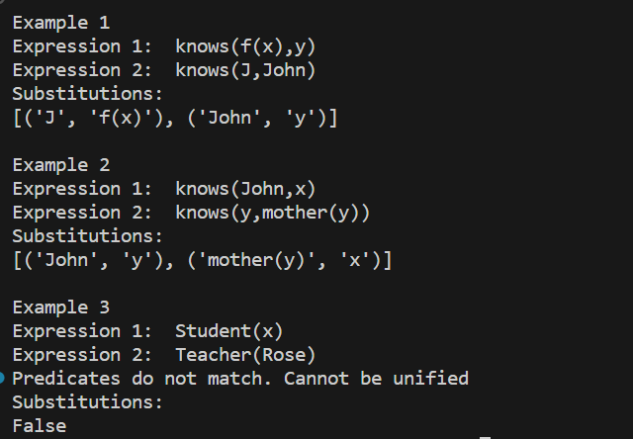

1. **Convert a given first order logic statement into Conjunctive Normal Form (CNF).**

def getAttributes(string):

expr = '\([^)]+\)'

matches = re.findall(expr, string)

return [m for m in str(matches) if m.isalpha()]

def getPredicates(string):

expr = '[a-z~]+\([A-Za-z,]+\)'

return re.findall(expr, string)

def Skolemization(statement):

SKOLEM_CONSTANTS = [f'{chr(c)}' for c in range(ord('A'), ord('Z')+1)]

matches = re.findall('[∃].', statement)

for match in matches[::-1]:

statement = statement.replace(match, '')

for predicate in getPredicates(statement):

attributes = getAttributes(predicate)

if ''.join(attributes).islower():

statement = statement.replace(match[1],SKOLEM_CONSTANTS.pop(0))

return statement

import re

def fol_to_cnf(fol):

statement = fol.replace("=>", "-")

expr = '\[([^]]+)\]'

statements = re.findall(expr, statement)

for i, s in enumerate(statements):

if '[' in s and ']' not in s:

statements[i] += ']'

for s in statements:

statement = statement.replace(s, fol_to_cnf(s))

while '-' in statement:

i = statement.index('-')

br = statement.index('[') if '[' in statement else 0

new_statement = '~' + statement[br:i] + '|' + statement[i+1:]

statement = statement[:br] + new_statement if br > 0 else new_statement

return Skolemization(statement)

print(fol_to_cnf("bird(x)=>~fly(x)"))

print(fol_to_cnf("∃x[bird(x)=>~fly(x)]"))

print(Skolemization(fol_to_cnf("animal(y)<=>loves(x,y)")))

print(Skolemization(fol_to_cnf("∀x[∀y[animal(y)=>loves(x,y)]]=>[∃z[loves(z,x)]]")))

print(fol_to_cnf("[american(x)&weapon(y)&sells(x,y,z)&hostile(z)]=>criminal(x)"))

**OUTPUT:**

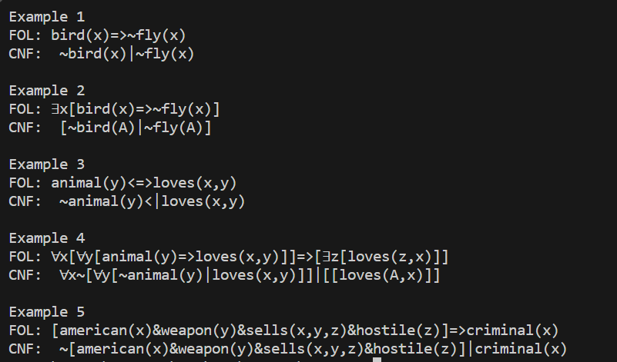

1. **Create a knowledge base consisting of first order logic statements and prove the given query using forward reasoning.**

import re

def isVariable(x):

return len(x) == 1 and x.islower() and x.isalpha()

def getAttributes(string):

expr = '\([^)]+\)'

matches = re.findall(expr, string)

return matches

def getPredicates(string):

expr = '([a-z~]+)\([^&|]+\)'

return re.findall(expr, string)

class Fact:

def __init__(self, expression):

self.expression = expression

predicate, params = self.splitExpression(expression)

self.predicate = predicate

self.params = params

self.result = any(self.getConstants())

def splitExpression(self, expression):

predicate = getPredicates(expression)[0]

params = getAttributes(expression)[0].strip('()').split(',')

return [predicate, params]

def getResult(self):

return self.result

def getConstants(self):

return [None if isVariable(c) else c for c in self.params]

def getVariables(self):

return [v if isVariable(v) else None for v in self.params]

def substitute(self, constants):

c = constants.copy()

f = f"{self.predicate}({','.join([constants.pop(0) if isVariable(p) else p for p in self.params])})"

return Fact(f)

class Implication:

def __init__(self, expression):

self.expression = expression

l = expression.split('=>')

self.lhs = [Fact(f) for f in l[0].split('&')]

self.rhs = Fact(l[1])

def evaluate(self, facts):

constants = {}

new_lhs = []

for fact in facts:

for val in self.lhs:

if val.predicate == fact.predicate:

for i, v in enumerate(val.getVariables()):

if v:

constants[v] = fact.getConstants()[i]

new_lhs.append(fact)

predicate, attributes = getPredicates(self.rhs.expression)[0], str(getAttributes(self.rhs.expression)[0])

for key in constants:

if constants[key]:

attributes = attributes.replace(key, constants[key])

expr = f'{predicate}{attributes}'

return Fact(expr) if len(new_lhs) and all([f.getResult() for f in new_lhs]) else None

class KB:

def __init__(self):

self.facts = set()

self.implications = set()

def tell(self, e):

if '=>' in e:

self.implications.add(Implication(e))

else:

self.facts.add(Fact(e))

for i in self.implications:

res = i.evaluate(self.facts)

if res:

self.facts.add(res)

def query(self, e):

facts = set([f.expression for f in self.facts])

i = 1

print(f'Querying {e}:')

for f in facts:

if Fact(f).predicate == Fact(e).predicate:

print(f'\t{i}. {f}')

i += 1

def display(self):

print("All facts: ")

for i, f in enumerate(set([f.expression for f in self.facts])):

print(f'\t{i+1}. {f}')

kb = KB()

kb.tell('missile(x)=>weapon(x)')

kb.tell('missile(M1)')

kb.tell('enemy(x,America)=>hostile(x)')

kb.tell('american(West)')

kb.tell('enemy(Nono,America)')

kb.tell('owns(Nono,M1)')

kb.tell('missile(x)&owns(Nono,x)=>sells(West,x,Nono)')

kb.tell('american(x)&weapon(y)&sells(x,y,z)&hostile(z)=>criminal(x)')

kb.query('criminal(x)')

kb.display()

kb_ = KB()

kb_.tell('king(x)&greedy(x)=>evil(x)')

kb_.tell('king(John)')

kb_.tell('greedy(John)')

kb_.tell('king(Richard)')

kb_.query('evil(x)')

**OUTPUT:**

